# Accessing the SAFE Desktop

1. Open a web browser and type the following: [**https://mycloud.jh.edu**](https://mycloud.jh.edu/)
2. You may be prompted to log in with your JHED ID and password.
3. Click on the Desktop tab, and select SAFE Desktop. Note: pop-ups must be enabled to properly load the SAFE!
4. The SAFE may take a few minutes to load the first time. Please take a moment to review the “SAFE - Read Me” file on the desktop to become familiar with the data security best practices. You should also see common applications like Word and Excel, as well as statistical tools such as RStudio, SAS, and Stata.
5. Every user also is assigned a secure file share to use to store sensitive data. To access this drive, click the yellow folder in the Windows status bar. You should see an “S” drive (named SDD), as pictured below:

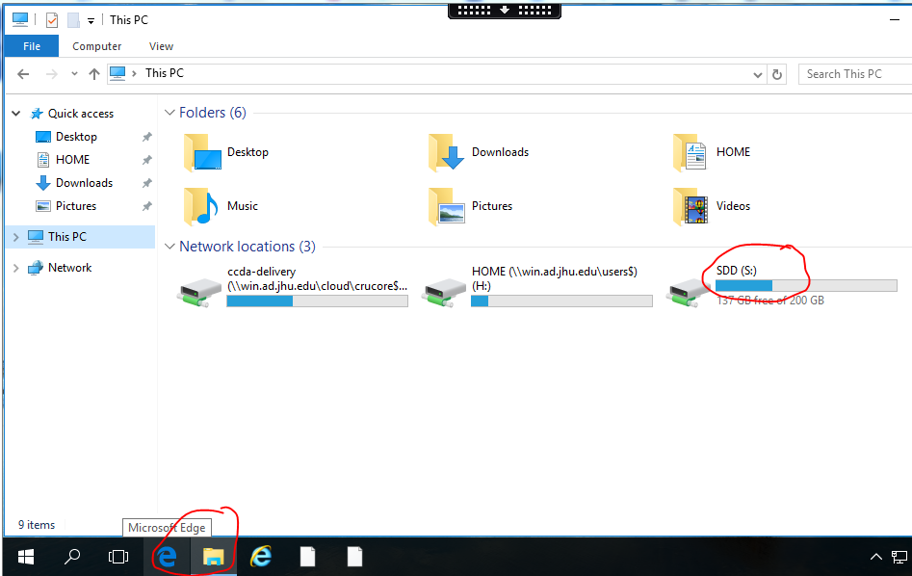

1. Folders that you have access to will appear in the list of folders.
2. The SAFE Desktop is intended to serve all of your research analytic and data storage needs. There should not be a need to move data off of the SAFE’s S drive. If you find that you need to use an application not available on the SAFE, please contact Bonnie Woods at bonnie.woods@jhu.edu. A steering committee meets regularly to evaluate requests for new software.